Luiz

Main Page

* Location: does not fit in the box - fix it!
* Change colors
* Implement the search
* Put images with bikes and link it to the bike description page (we probably can use JSON)
* 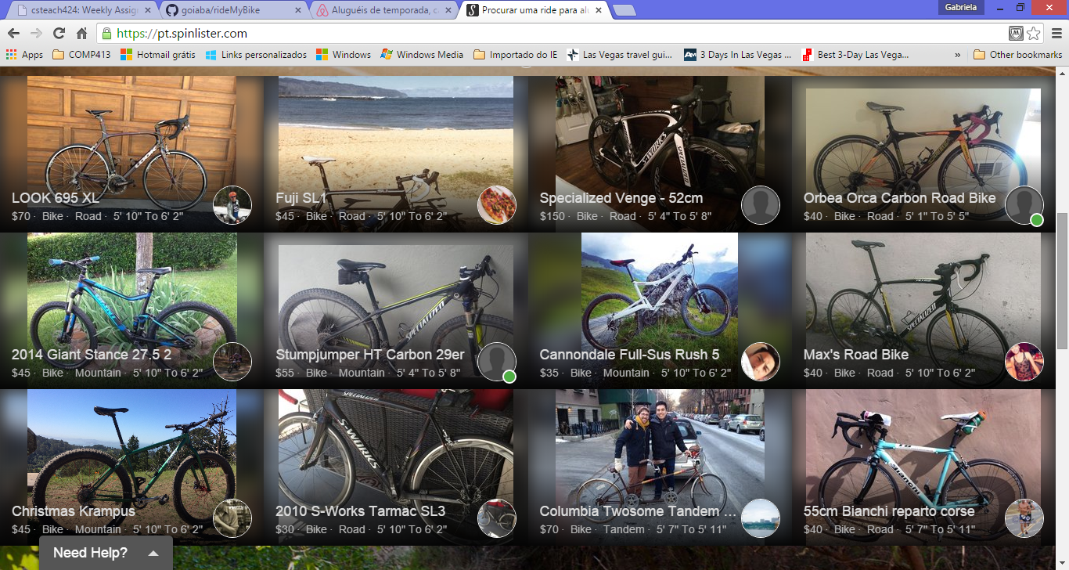

Gabi

How it works – create how it works page!

User Registration/Bike registration: Change the design, use the whole page, put some image, bigger font and labels/box – use same color as main page!

Login – change the design color

Farhad

Bike details: Get the information from a JSON (Name, type, description, model, frame, reviews…)

Change the colors/design

Contact owner and Write review – button: create dialog box/modal in Bike details page with form

* Can we use frameworks from now on? – Ask to the professor

<https://color.adobe.com/My-Color-Theme-color-theme-7172331/>

Colors

#3E9937

#C6FF03

#883AFF

#10B503

#1D0D8F

